NAME
ADDRESS
DATE

NAME OF MP/OR OTHER ELECTED OFFICIAL
House of Commons
London
SW1A 0AA

Dear

MAKING THE CASE FOR EXAMINING THE LEGACIES OF ENSLAVEMENT ON AFRIKAN HERITAGE COMMUNITIES

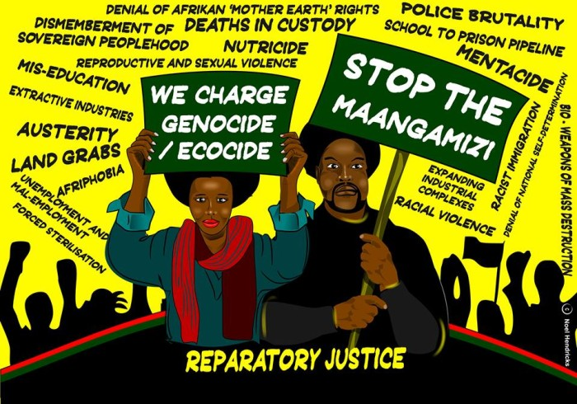

I am one of your constituents. The present-day impact of the Maangamizi (Afrikan ‘Hellacaust’ of chattel, colonial and neo-colonial forms of enslavement) on my life in this constituency compels me to address this postcard to you. This exacerbates my concern about the lack of implementation of the reparatory justice-related sections of the Durban Declaration & Programmes of Action arising from the 2001 United Nations World Conference Against Racism, Racial Discrimination, Xenophobia & Related Intolerance and the ‘International Decade for People of African Descent’ (2015-2024) proclaimed by the UN General Assembly. Such lack of recognition of the causes and consequences of the Maangamizi is aggravating sufferings by our Afrikan communities of Afriphobia and other forms of anti-Black Racism, in addition to further manifestations of the Maangamizi, as depicted on the front of this postcard.

It was recently highlighted by historian David Olusoga the UK Treasury Office tweeted its “surprising #FridayFact that “Millions of you helped end the slave trade through your taxes” accompanied by an image of Afrikans being marched, in yokes and ropes, into slavery.The tweet continued:

Did you know? In 1833, Britain used £20 million, 40% of its national budget, to buy freedom for all slaves in the Empire. The amount of money borrowed for the was so large that it wasn’t paid off until 2015. Which means that living British citizens helped pay to end the slave trade.”

What the Treasury Office failed to mention, however, was that the £20m which represented 40% of the national budget was paid out to the 46,000 enslavers to compensate them for the ‘loss’ of their so-called ‘property’ in chattelised people of Afrikan heritage. By one calculation that is the modern equivalent of about £17bn: As an equivalent measure, 40 per cent of Government expenditure now would be more than £300 billion. https://www.theguardian.com/commentisfree/2018/feb/12/treasury-tweet-slavery-compensate-slave-owners.

I wish to draw your attention to the fact that a petition has been started about this misuse of taxes: https://www.change.org/p/refund-our-taxes-paid-to-compensate-enslavers by those who are conscientious objectors to tax fraud and who also share the disgust of all those who are now finding out, that for many generations, monies were extorted from all those paying taxes in Britain, right up until 2015, for the compensation that was the unjust reward legislated by the 1833 Slavery Abolition Act. This is a news report about the above petition: https://www.bristolpost.co.uk/news/bristol-news/petition-demands-british-government-refunds-1227302.

As an elected official, I request that you contribute to halting and reversing the enduring injustices of the Maangamizi for Afrikan Heritage Communities by:

1. Initiating a lobby in Parliament on Afrikan Heritage Communities Legacies of Enslavement;
2. Supporting the call to establish an All-Party Parliamentary Group on Afrikan Heritage Communities Legacies of Enslavement;
3. Supporting the Afrikan Heritage Communities’ (AHC) demand for the establishment of UK and EU All-Party Parliamentary Commissions of Inquiry for Truth & Reparatory Justice.”

I would like to meet with you to discuss these matters further.

Please respond in writing to the above requests.

Yours sincerely,

[Signature]

